Subject Name:

Source Code Management

Subject Code:

22
CS
003

Session:

2022
-
2023

Department:

DCSE



Submitted By: Submitted To:
Pushpinder Singh Dr. Aditi.
2210990693-First Year
G27-A

List of programs
S.No. | Program Title | Page No.
Exp 1. | Setting up of Git Client. | 3-5
Exp 2. | Setting up GitHub Account. | 6-8
Exp 3. | Generate Logs. | 9-11
Exp 4. | Create and visualize branches. | 12-13
Exp 5. | Git life cycle description. | 14-16
Exp 6. | Add collaborators on GitHub Repo.
Exp 7. | Fork and commit.
Exp 8. | Merge and resolve conflicts created due to own activity.
Exp 9. | Reset and revert.

Experiment-1
Aim: To set up Git Client
Reference: https://git-scm.com/download Procedure:
- Browse to the official Git website: https://git-scm.com/downloads
- Click the download link for windows and allow the download to complete.
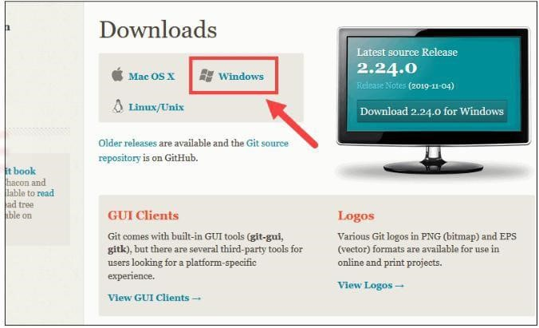

- Browse to the download location (or use the download shortcut in your browser). Double click the file to extract and launch the installer.

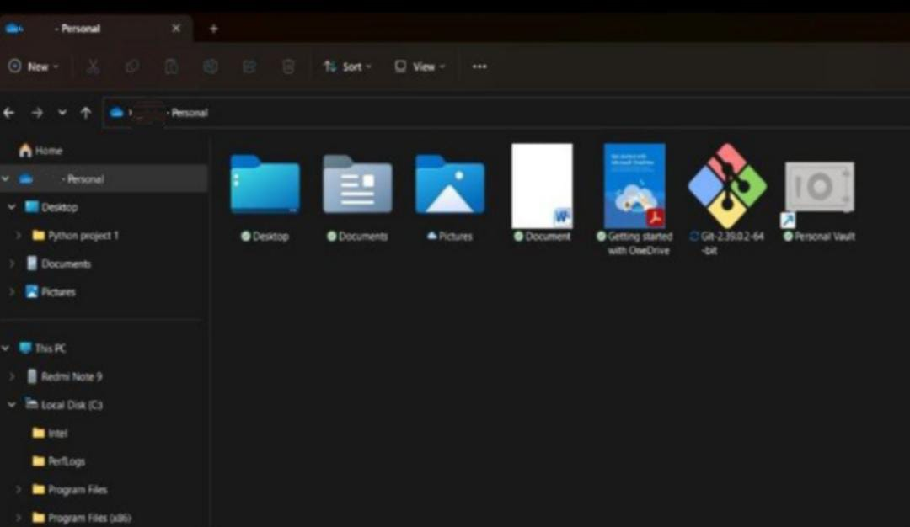
- Allow the app to make changes to your device by clicking Yes on the user Account Control dialog that opens.
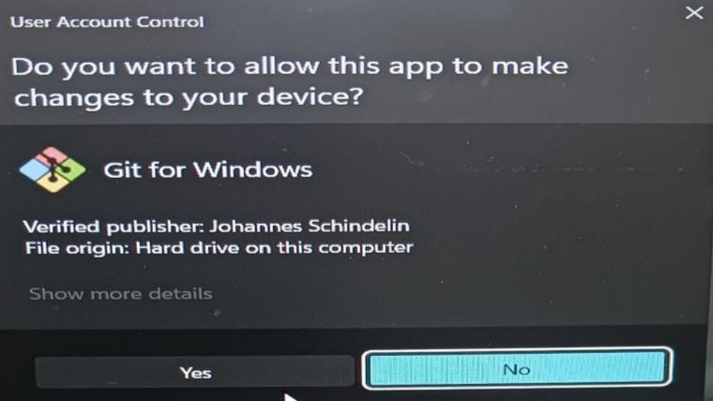
- Review the GNU General Public License, and when you are ready to install, click Next.
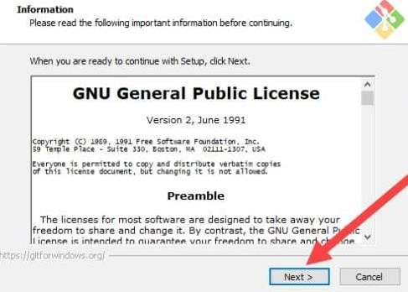

- The installer will ask you for an installation location. Leave the default unless you have a reason to change it, click Next.
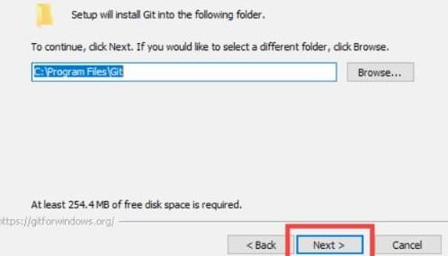
- Once the installation is complete, tick the boxes to view the Release Notes or Launch Git Bash, then click Finish.

Result: We have successfully set up our Git Client.

Experiment-2
Aim: To set up GitHub Account.
Reference: https://github.com/ Procedure:
- Browse to the official Git website: https://github.com/ . Following window will appear.
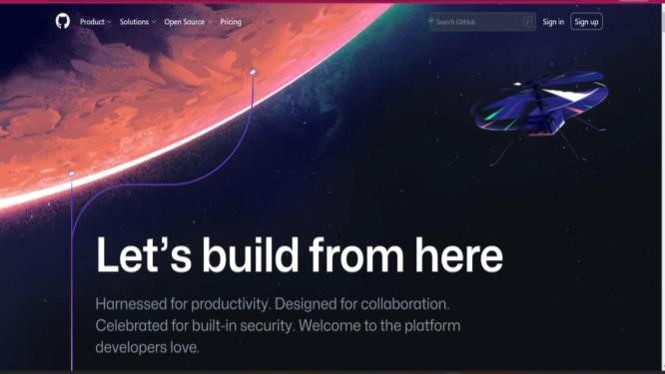
- Click on the Sign Up option above and the following window will appear.
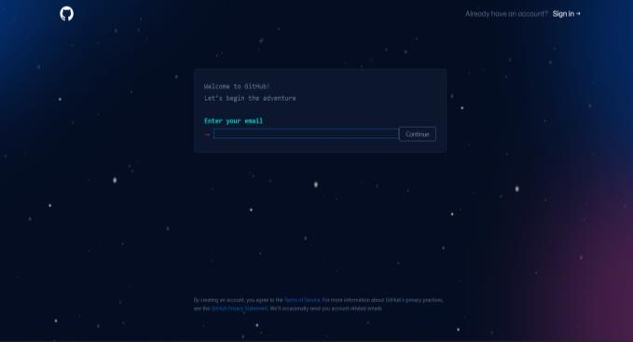
- Enter your Email Address and click on Continue.
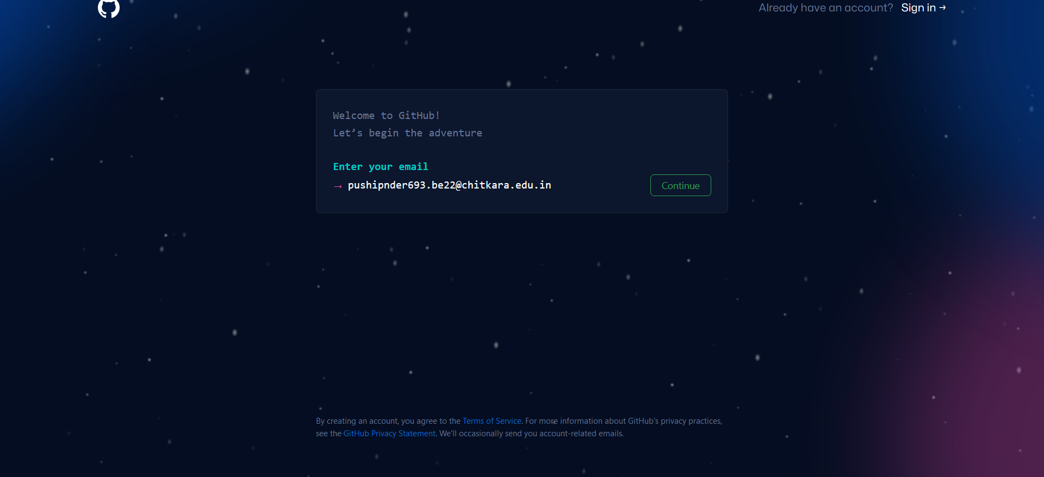
- Create a password for your new GitHub account, and enter a username too. Next choose whether you want to receive updates and announcements via email, and then select Continue.
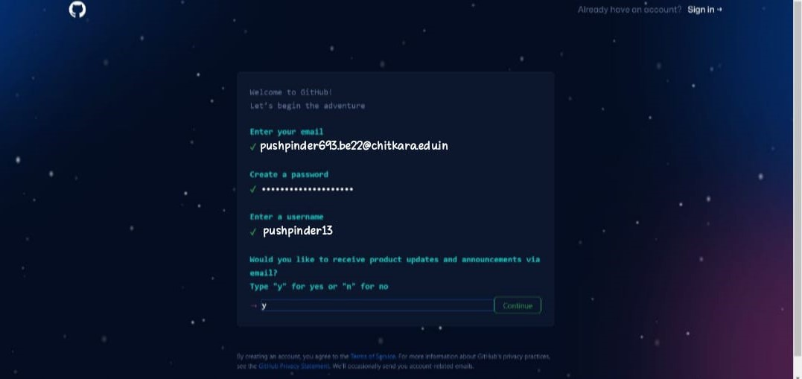
- After you verify your account, select the Create Account Button.
- After clicking on Create Account you will end up with the following window.
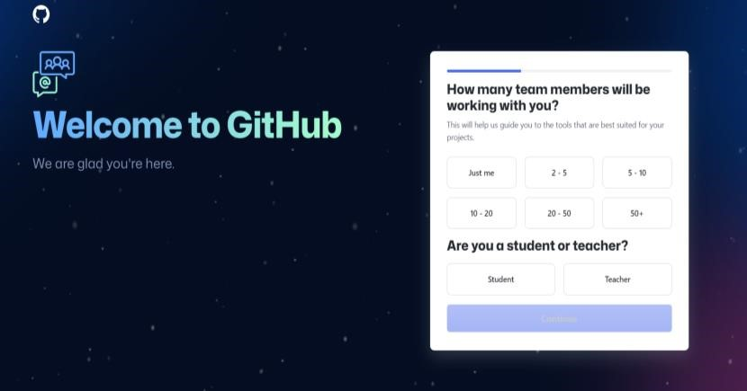
- After completing the above form, you will see the following window. Click on Continue for Free to create an account.
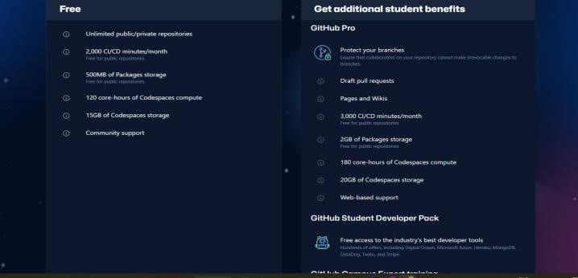
- After clicking on Continue for Free, following window will appear indicating successful registration of account.
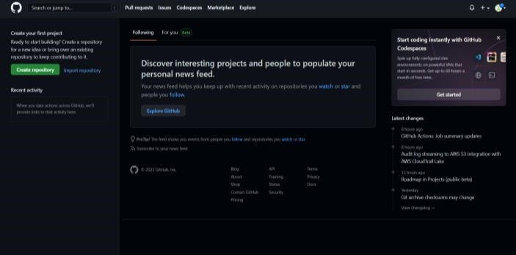
Result: We have successfully created a GitHub Account
.

Experiment-3
Aim: To generate Logs
References: https://git-scm.com/ Procedure:
- Open GitBash and initialize empty Git Repository.
- Use touch command and then use vi command (vi is used to edit the files if it does not exist), it creates a new file.
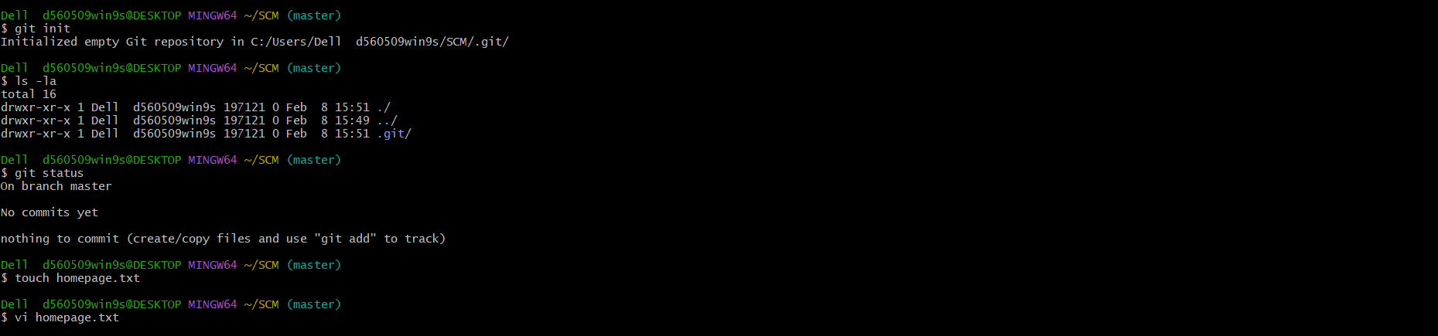
- With using vi empty file is created in which we have to enter text and to exit press esc and colon(:) and write wq and then press Enter.
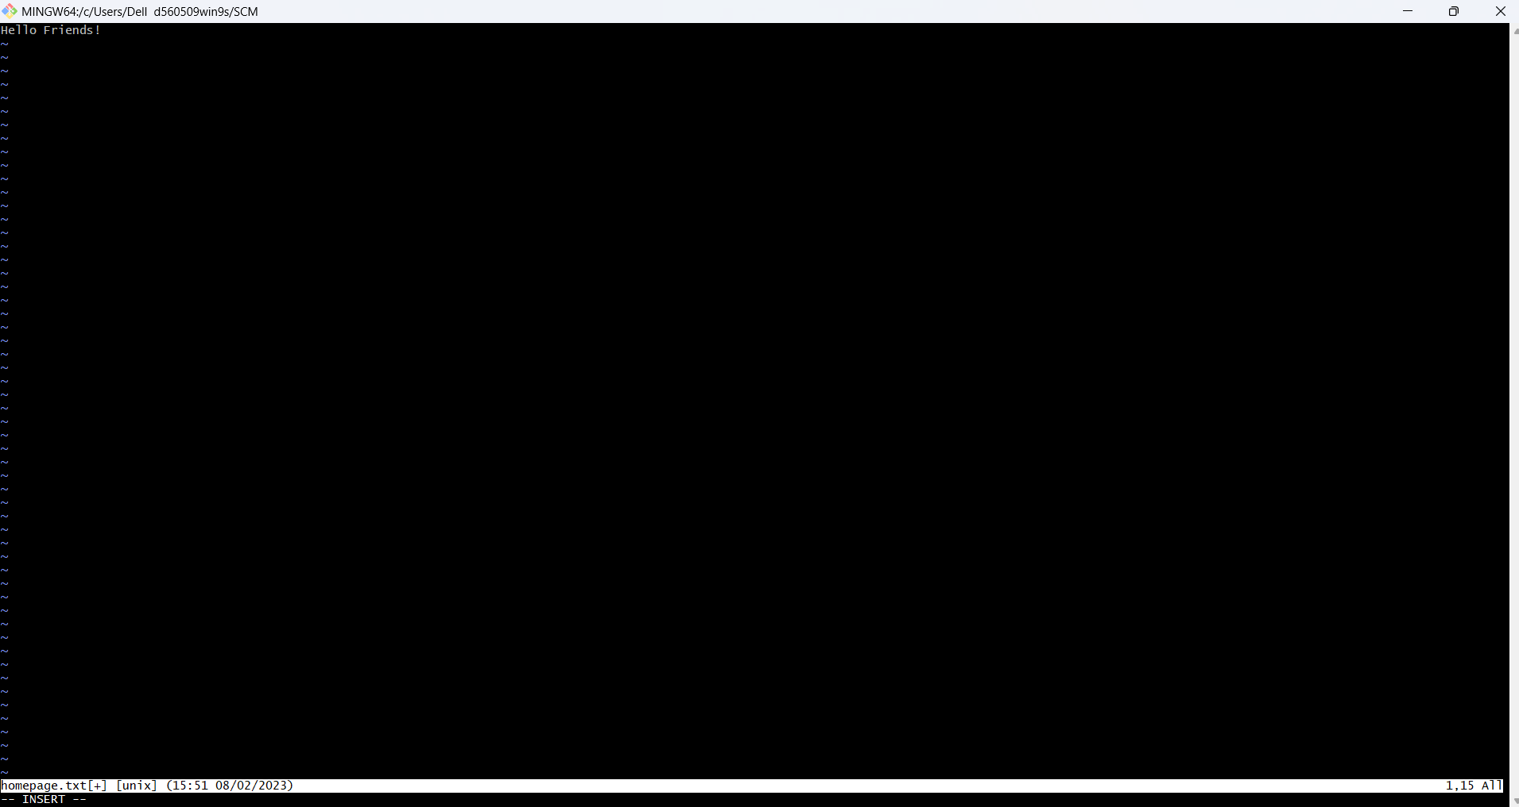

- After creating the text file and add the text file. The above procedure should look like as follows.
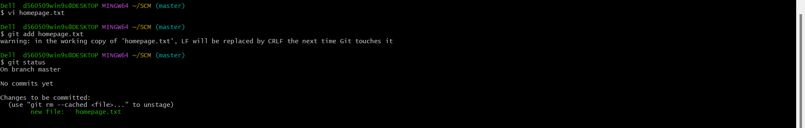

- Commit the text file.
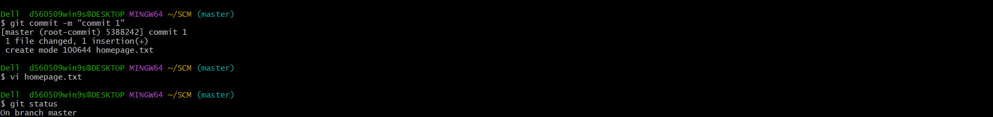

- Use git log command to check logs. It should look like following.
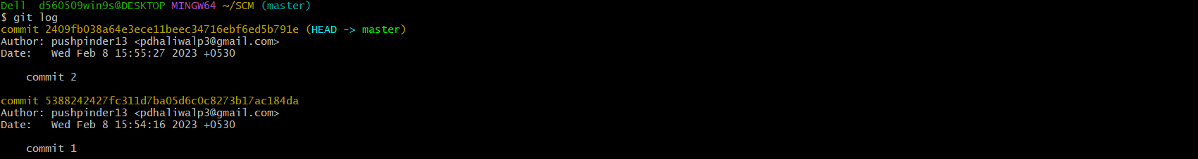

Result: We have successfully checked the logs.

Experiment-4
Aim: To create and visualize branches
References: https://git-scm.com/ Procedure:
- Open GitBash and initialize the Git Repository.
- Now check the present branches using branch command.
- Now add a new branch using git branch <branch name> command. Then again use branch command to check the branches.
- Now, to switch branches, use checkout command and then add two text files using touch and vi commands. The procedure should look like the following.
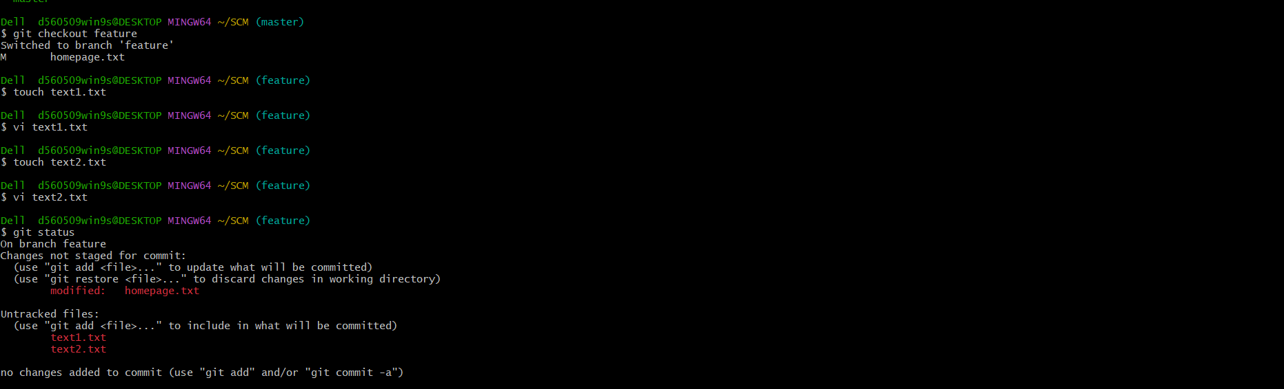
- Now use add and commit commands. Then again use checkout command. Now use merge and git log –oneline commands. The process should look like the following.
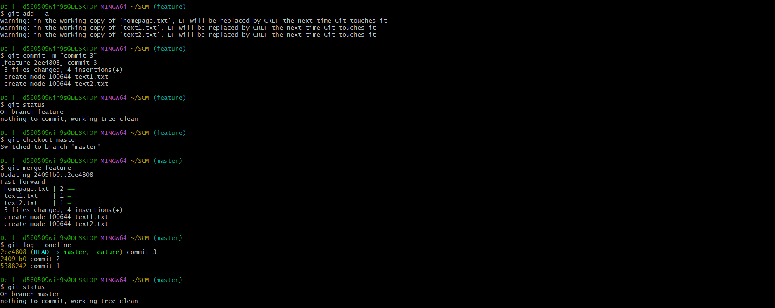
Result: We have successfully created and visualized branches.

Experiment-5
Aim: Git lifecycle description References: https://git-scm.com/ Description:
Flowchart for Git Lifecycle is as follows -
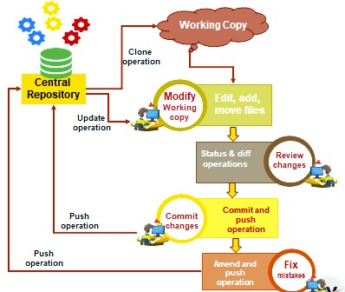
(I)The overall workflow of git lifecycle is as follows:
- Firstly, clone the Git repository as a working copy.
- Now modify the working copy by adding/editing files in your *working tree.
- Now selectively stage just those changes you want to be part of your next commit, which add only those changes to the **staging area.
- Now commit the changes. If everything goes well, push the changes to the repository. (If something is wrong after committing the changes, then correct the last commit and again push the changes to the repository.)This will store the snapshots permanently to your ***Git Directory.
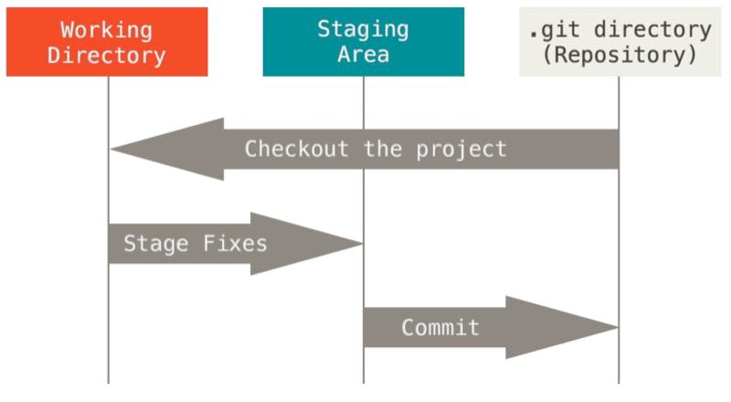
*Working tree

is a single checkout of one version of the project. These files are pulled out of the compressed
database in the
***Git Directory

and placed on disk for you to use or modify.

**Staging area

is a file, generally contained in your
***Git Directory
, that stores information about what will go
into your next commit. Its technical name in Git parlance is the “
index
”, but the phrase “
stagi
ng area
” works just as
well.

***Git directory

is where Git stores the metadata and object database for your project. This is the most important
part of Git, and it is what is copied when you

clone

a repository from another computer.

(II)When introduced to Git, we will find that there are Three Main Stages in the git lifecycle; modified, staged and committed.
- Modified means that you have changed the file but have not committed it to your database yet.
- Staged means that you have marked a modified file in its current version to go into your next commit snapshot.
- Committed means that the data is safely stored in your local database.
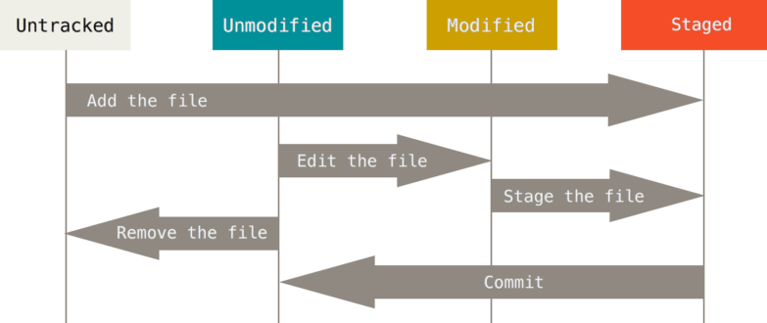
If a particular version of a file is in the
***
Git directory
, it’s

considered

committed
. If it has been modified and was added to the
staging area, it is

staged
. And if it was changed since it was checked
out but has not been staged, it is

modified

